3SF CONTINUES TO ROLL OUT CRITICAL TRAINING PROGRAMS
Between June and August of 2026, the 3SF project hosted two significant training seminars to strengthen the capacity of South Sudan Finance Sector stakeholders to discharge their duties. From June 27th to July 2nd, the 3SF IFRS9 consultant, Mr. Japhet Ngura, facilitated a four-day workshop at BoSS for Bankers, Insurance Providers, SACCOS & Microfinance Institutions, and Forex Bureaus.
Each sector was scheduled independently to maximize interactions unique to them. The Banking sector benefited from knowledge and practice intended to enable a deeper understanding of IFRS9, the ability to apply the Three-Stage Impairment Model, understand the ECL Components of PD, LGD & EAD, the capacity to interpret staging criteria and movement, appreciate forward-looking and macroeconomic considerations & align themselves with the regulatory expectations of the Bank of South Sudan.
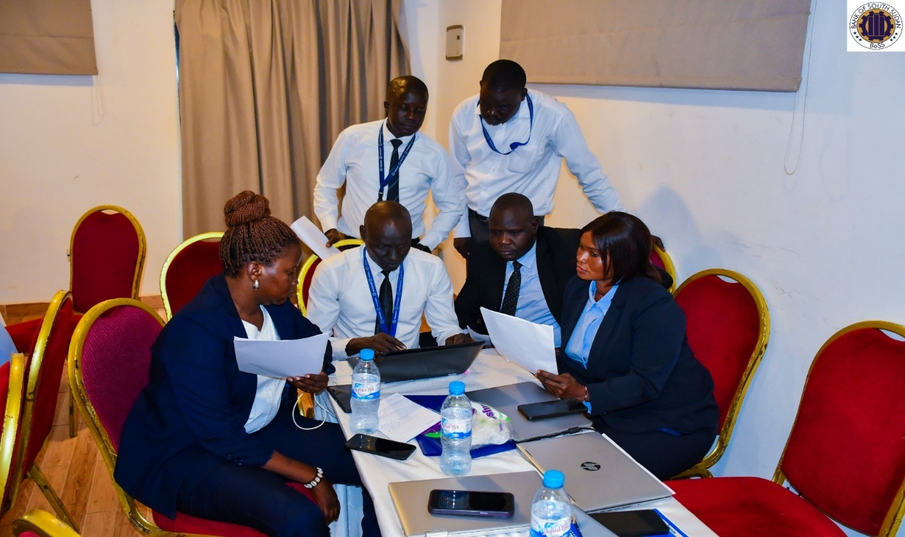

The SACCOS & Microfinance Institutions were coached on understanding and applying IFRS requirements, applying expected credit loss (ECL) using simplified models, strengthening loan monitoring provisions & reporting, while the insurance sector earned wisdom on IFRS9 requirements for the insurance industry, strengthening capacity to apply expected credit loss (ECL), supporting compliance with regulatory requirements issued by the Bank of South Sudan and enhancing financial reporting quality, governance and risk management.
Forex Bureaus were not left behind; they were schooled in understanding IFRS9 classification & measurement, applying the impairment requirements & the simplified ECL approach, performing critical ECL calculations using forex bureau exposures, understanding regulatory reporting and BoSS expectations, assessing the financial statement impact of IFRS 9, and strengthening controls, compliance, governance and disclosures.
The seminar brought together over 50 participants across the four sectors. It is anticipated that the learning will enhance several merits in the South Sudan Finance Sector, as anticipated in the vision of the project, including improved credit risk management, better quality and transparency in financial statements in line with world-class standards, more stringent and reliable banking sector supervision, and above all improved comparability, with the consequence of boosting investor confidence.
From the 3rd to the 7th of August 2026, the 3SF Monitoring and Evaluation Consultant, Dr, Lawrence Nduva Munyaka, facilitated yet another workshop that brought together 46 participants, including BoSS division heads, directors, Monitoring and Evaluation officers at BoSS, and other technical staff. The core objectives of the workshop included enhancing understanding of the 3SF project, strengthening knowledge of results-based management and results framework, clarifying institutional M&E roles, strengthening data collection management, verification, and reporting, improving the use of M&E for management decisions, and developing departmental implementation and monitoring plans.
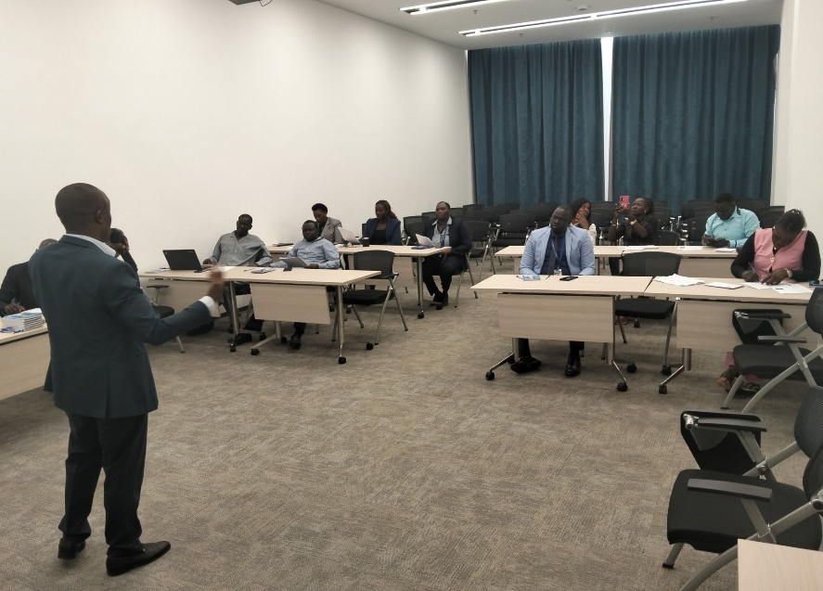

The gathering was loaded with professional content that ranged from M&E foundations, institutional transformation, Theory of Change, results-based management, results framework, indicators, systems, departmental roles, data sources, evaluation learning, adaptive management, beneficiary feedback, to risk management & analysis, Kobo Toolbox training, action planning, and institutional integration.
It is expected that the participants will apply the learning to develop department-specific M&E focal point arrangements and clarify reporting responsibilities under the 3SF M&E framework, and also provide standardized departmental monitoring data quality and reporting templates aligned with the 3SF results framework, among other professional changes.
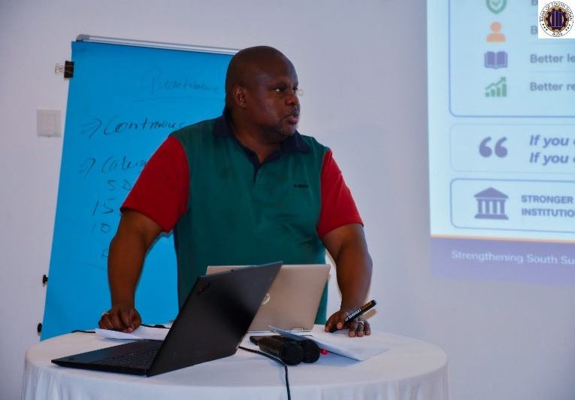
Both workshops utilized a plethora of methodologies to maximize understanding and appreciation, including interactive presentations, content analysis, case studies, group and individual practicum, situational analyses and critiques, moderated discussions, action planning, dashboard demonstrations, reporting simulations, reflection sessions, focus group discussions, review of informative videos and audiovisual material.

It is worth noting that training is a major component of the project and several other capacity-building exercises are in the offing. Currently, the Communication Specialist for the project, together with the Department of Communication and Public Relations, is planning a training trip to Nimule to conduct a workshop on Official Communication, Organizational Protocol and Etiquette for the BoSS Nimule branch. This follows similar exercises that have already been undertaken in the Wau and Aweil BoSS branches. Plans are also underway to roll out a comprehensive training for BoSS staff on Business English and Communication, with the intent of improving official spoken and written communication by BoSS staff.
___________________________________ENDS_____________________________________

